Rough reflection

Torch light reflects brightly off a mirror.
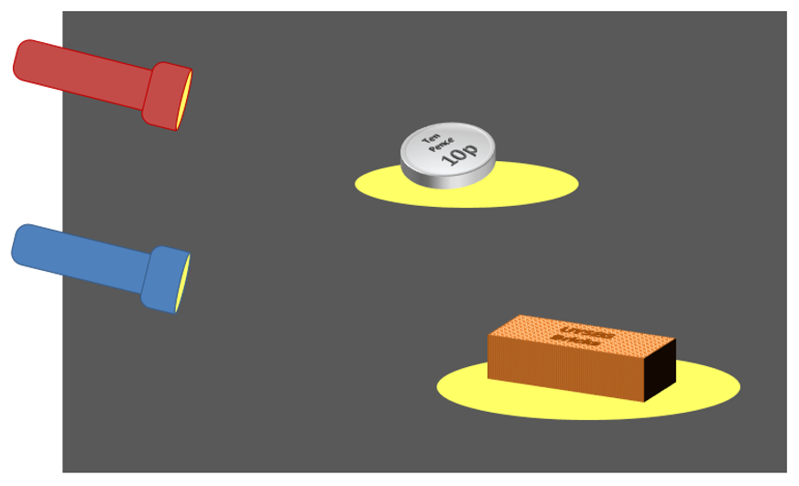

What happens when a torch is shone on other objects?
Which of these statements do you think are right?
For each statement, tick (✓) one column to show what you think.
Places |  | I am sure this is right | I think this is right | I think this is wrong | I am sure this is wrong
A | Light reflects off the shiny coin
B | Light reflects off the coin like a mirror (all in one direction)
C | Light reflects off the dull brick
D | The rough surface of the brick reflects light in all directions

Physics > Big idea PSL: Sound, light and waves > Topic PSL1: Sound and light > Key concept PSL1.2: Characteristics of light
Diagnostic question
Rough reflection

Overview
Learning focus: | Light is reflected from all surfaces, and off a flat mirror it is reflected in a single direction.
Observable learning outcome: | Explain how light reflects off rough surfaces.
Question type: | Confidence grid
Key words: | Reflect, ray, scatter

What does the research say?
When light reflects Anderson and Smith (1986) found that, out of 125 ten and eleven year olds, about 60% described light bouncing off only mirrors and not off other opaque objects. Just 20% thought light did bounce off opaque objects, with only 2% suggesting it is scattered.
This question explores students’ understanding of how light reflects off different types of surface.
Ways to use this question
Students should complete the confidence grid individually. This could be a pencil and paper exercise, or you could use an electronic ‘voting system’ or mini white boards and the PowerPoint presentation.
If there is a range of answers, you may choose to respond through structured class discussion. Ask one student to explain why they gave the answer they did; ask another student to explain why they agree with them; ask another to explain why they disagree, and so on. This sort of discussion gives students the opportunity to explore their thinking and for you to really understand their learning needs.
Differentiation
You may choose to read the questions to the class, so that everyone can focus on the science. In some situations it may be more appropriate for a teaching assistant to read for one or two students.
Expected answers
A, C and D are correct. It could be argued that B is partly correct.
How to respond - what next?
Light reflects off all surfaces and off the smooth face of the coin it reflects as it would off a mirror.
When light reflects off the brick it obeys the law of reflection and the angle of reflection equals the angle of incidence. But because the surface is rough, the light hits the surface at many different angles. This makes the light scatter in all directions.
If students have misunderstandings about how light is made to scatter in all directions off a rough surface, it can help to image (or having a go at) throwing a ball at a flat wall and comparing that with throwing the same ball at a very uneven surface – like a pile of rocks.
The following BEST ‘response activity’ could be used in follow-up to this diagnostic question:
- Response activity: Desert island rescue
Acknowledgments
Developed by Peter Fairhurst (UYSEG).
Images: UYSEG
References
Anderson, C. W. and Smith, E. L. (1986). Childrens' conceptions of light and colour: developing the concept of unseen rays. Annual meeting of the American Educational Research Association. Montreal, Canada.

